Smart Gas Leakage Detector

***For the fulfillment of the 4th Semester B. Tech degree SPHO Project***

***Submitted By***

**Navneet Nipu Roll No.: 201710518**

**Aman Srivastava Roll No.: 201710522**

**Abhishek Kumar Sahu Roll No.: 201710525**

**Electronics and Communication Engineering**



***Under The Guidance of***

**Prof. Swagat Kumar Samantaray**

**NATIONAL INSTITUTE OF SCIENCE & TECHNOLOGY**

**Institute Park, Palur Hills, Berhampur, Odisha – 761008, INDIA**

# Certificate for Presentation

This is to certify that the project entitled ***“smart gas leakage detector”*** carried out by **Mr.Navneet Nipu, Mr.Aman Srivastava, Mr.Abhishek Kumar Sahu** is up to the satisfaction and is allowed for the presentation.

**Prof. Swagat Kumar Samantaray**

*(Faculty Advisor)*

**Prof. Rajesh Kumar Dash**

*(SPHO Coordinator)*

# ABSTRACT

LPG gas is supplied in pressurized steel cylinders. As this gas is heavier than air, when it leaks from a cylinder it flows along floor and tends to settle in low spots such as a basement. This can cause fire or suffocation if not dealt with. Here is a gas leakage alarm circuit that detects the leakage of LPG gas and alerts the user through audio-visual indications. LPG gas leakage detector system can be easily integrated into a unit that can sound an alarm or give a visual suggestion of the LPG concentration. The sensor has both admirable sensitivity and rapid response time. Generally all the LPG gas Sensor Module are made using microcontroller which are very much expensive and not affordable. The main objective of this design is to make the circuit using IC’s and sensors. Also it will send a notification through the wireless so that if the person is not in the home then also he will get the notification through the mobile app using IoT.

Also when the circuit will detect the gas leakage then it will send the notification and automatically turn the regulator in off position by rotating the knob using the servo motor.

# ACKNOWLEDGEMENT

I give my sincere thanks to **Prof. Swagat Kumar Samantaray,** project advisor for giving me the opportunity and mentoring me to work for the project.

I give a special thanks to **Prof. Rajesh Kumar Dash,** SPHO Project Coordinator for his valuable time and making everything to happen.

I acknowledge with immense pleasure the sustained interest, encouraging attitude and constant inspiration rendered by **Prof. Sukanta Mohapatra** (Chairman), **Prof. Sangram Mudali** (Director), **Prof. Geetika Mudali (Placement Director)**, **Prof. (Dr.) Ajit Kumar Panda** (Dean), and **Dr. Satya Sopan Mahato** (HOD, School of Electronics & Communication Engineering) N.I.S.T. for their continued drive for better quality in everything that happens at N.I.S.T. and selfless inspiration has always helped us to move ahead.

1. **Navneet Nipu**
2. **Aman Srivastava**
3. **Abhishek Kumar Sahu**

**CONTENTS**

|  |  |  |
| --- | --- | --- |
| ABSTRACT | …………………….……………………………... | 3 |
| ACKNOWLEDGEMENT | …………………….……………………………... | 4 |
| INTRODUCTION | …………………….……………………………... | 6-7 |
| OVERVIEW OF PROJECT | …………………….……………………………... | 8 |
| HARDWARE REQUIREMENT | …………………….……………………………... | 9-12 |
| SOFTWARE REQUIREMENT | …………………….……………………………... | 13-17 |
| PROJECT DESCRIPTION | …………………….……………………………... | 18-24 |
| PROJECT OUTCOME | …………………….……………………………... | 25 |
| APPLICATION | …………………….……………………………... | 26 |
| CONCLUSION | …………………….……………………………... | 27 |
| REFERENCES | …………………….……………………………... | 28 |

# INTRODUCTION

Domestic LPG cylinders if not handled properly, can lead to disastrous and fatal consequences. It’s almost impossible to have LPG blast on its own without related factors. Firstly, a gas leak from the cylinder or regulator gets mixed with air, forming a combustible mixture. To complete the fire triangle we need a spark or a source of ignition. This spark ignites the combustible LPG-air mixture and this leads to an explosion. Such explosions normally take place during the odd hours when people are not alert, like right after getting out of bed if one uses electrical appliances or uses the gas lighter.

* 1. **Causes of LPG Gas Leakage Accidents**
* **Damaged gas pipes**

With time, the seals that hold and connect the piping of these appliances can wear out corrode. The corrosion of these seals and pipes can easily cause gas leaks into your home. Poor piping is extremely common with older homes, and can allow gas to seep into the home.

* **Forgot to turn off the cylinder regulator during night**

We should turn off the cylinder regulator when we are going out from our home for a long period of days. Also we should keep windows open during the night.

* **Carelessness of the consumers**

Many of the consumers have a very careless attitude toward the gas cylinder installations and its uses. Most of the consumer keeps the gas cylinder in a close and compact area and also forgot to do daily checks for the gas pipes leakages

## 

**Fig.1**.**1 Accidents due to LPG gas leakage (a) 12 April 2019;Athmallik, Odisha (b) 30October2017;Chandighar,Panchkula**

**1.2 Statistics related to the accidents due to LPG gas leakage**

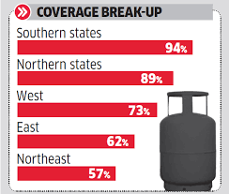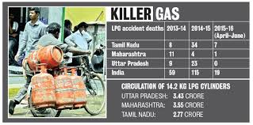

## 

## 

# Fig. 1.2 (a) Stats showing that the more lpg leakage related accidents take place in southern states (b) Data showing that Tamil Nadu shares the maximum shares followed by Maharashtra and Uttar-Pradesh

# 1.3 Precautions to reduce gas leakage

* Always to keep the regulator knob in off position when not in use
* Kitchen and the cooking area should be well ventilated.
* ISI approved rubber tubes and regulators are to be used.

**1.4 Existing Devices for gas leakage detection**

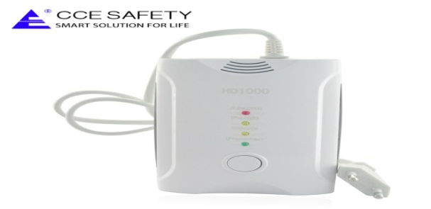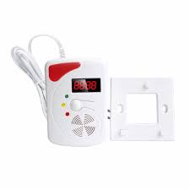

**Fig. 1.3 Microcontroller based electronic gas sensor kits**.

Due to huge number of accidents and lack of awareness of consumers for LPG gas leakages there is a need of smart device for continuous monitoring of gas leakages and provide alarms before any catastrophic failure happen.

# OVERVIEW OF THE PROJECT

In this project we are using controller, sensors, wi-fi module ,servo motor, mobile application and integrating them using IoT to build a smart device which can sense and detect gas LPG leakage and can send alarm signal to the person through the mobile application so that the person can switch off the regulator to avoid catastrophic situations.

In this project we are interfacing different electronics and generating a new device which can reduce accidents related to the LPG gas leakage.

GAS LEAKAGE DETECTOR CIRCUIT

9V DC POWER SUPPLY

GAS REGULATOR

MOBILE APP (NOTIFICATION)

SERVO MOTOR

WI-FI MODULE

ARDUINO

BOARD

C

**Fig. 2.1: Block diagram of smart gas leakage detector**

**3. HARDWARE REQUIRMENTS**

**3.1 MQ-6 GAS SENSOR**

This sensor belongs to the MQ series of the gas sensor. In this series, there are different sensors depending upon the sensitivity towards a particular gas.MQ-6 basically senses the gas which has propane and butane content e.g. LPG gas. This sensor has a very high sensitivity towards LPG gas and can detect even a very low concentration of LPG.

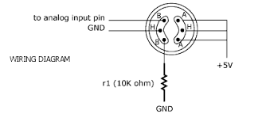

**Fig. 3.1 Pin Layout of the MQ-6 sensor**

**3.2 IC 7805**

IC 7805 belongs to the 78xx series of the IC family. This series is basically used for the voltage regulation purpose. The last two digits of the IC name represent the output voltage of the IC for e.g. ic7805 has the input voltage range of (7v-17v) and the output range of the (4.9v to 5.1v).The reduction of voltage results in the loss of power which is dissipated as the heat from the heat sink of the IC 7805.

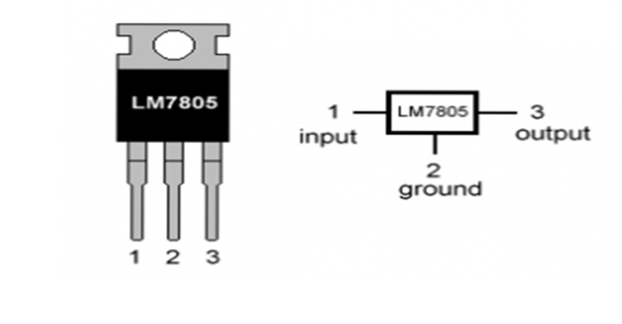

**Fig. 3.2 Pin Layout of the LM7805**

**3.3 IC LM393**

LM 393 is the voltage comparator Op-Amp which is use compares the voltages between the reference voltage and the output voltage of the sensor. As the output of the sensor voltage will be high with respect to the reference voltage then it will send the high voltage to the output terminal of the Op-Amp.

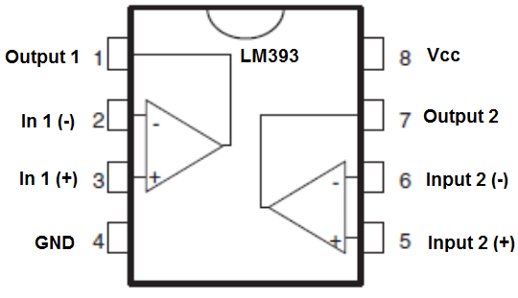

**Fig. 3.3 Pin layout of the LM393**

**3.4 ARDUINO-UNO (MICROCONTROLLER AT-MEGA)**

Arduino is an open source hardware and software company, project and user community that designs and manufactures single board microcontroller and microcontroller kits for building digital devices and interactive objects that can sense and control both physically and digitally.

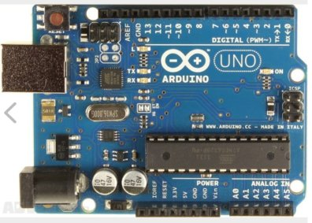

**Fig. 3.4 Arduino Uno with ATMEGA microcontroller**

**3.5 WI-FI MODULE**

The is an ESP8266 with 1 MB of built-in flash, allowing for single-chip devices capable of connecting to Wi-Fi. The ESP8266 Wi-Fi Module is a self-contained SOC with integrated TCP/IP protocol stack that can give any microcontroller access to your Wi-Fi network. The ESP8266 is capable of either hosting an application or offloading all Wi-Fi networking functions from another applications.

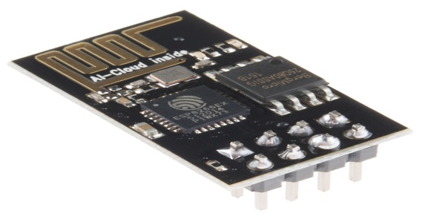

**Fig. 3.5 ESP8266 wi-fi module**

**3.6 SERVO MOTOR**

A servo motor is an electrical device which can push or rotate an object with great precision. It control of angular or linear position, velocity and acceleration. It consists of a suitable motor coupled to a sensor for position feedback. Servomotors are used in applications such as robotics, CNC machinery or automated manufacturing. If you want to rotate and object at some specific angles or distance, then you use servo motor. It is just made up of simple motor which run through servo mechanism.

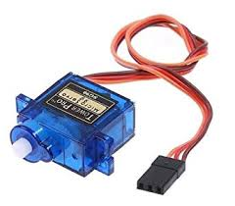

**Fig 3.6 High torque dc-servo motor**

**3.7 PIEZO BUZZER**

This is an external buzzer which Operates in wide range of voltage (9V to 24V). Most commonly used in at 9V & 12v.This is used to alarm the people present in the house.

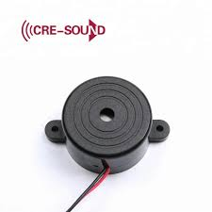

**Fig. 3.7 Piezo Buzzer**

**4. SOFTWARE REQUIRMENTS**

**4.1 ANDROID STUDIO**

It is based on the IntelliJ IDEA, a Java integrated development environment for software, and incorporates its code editing and developer tools. To support application development within the Android operating system, Android Studio uses a Gradle-based build system, emulator, code templates, and Github integration.

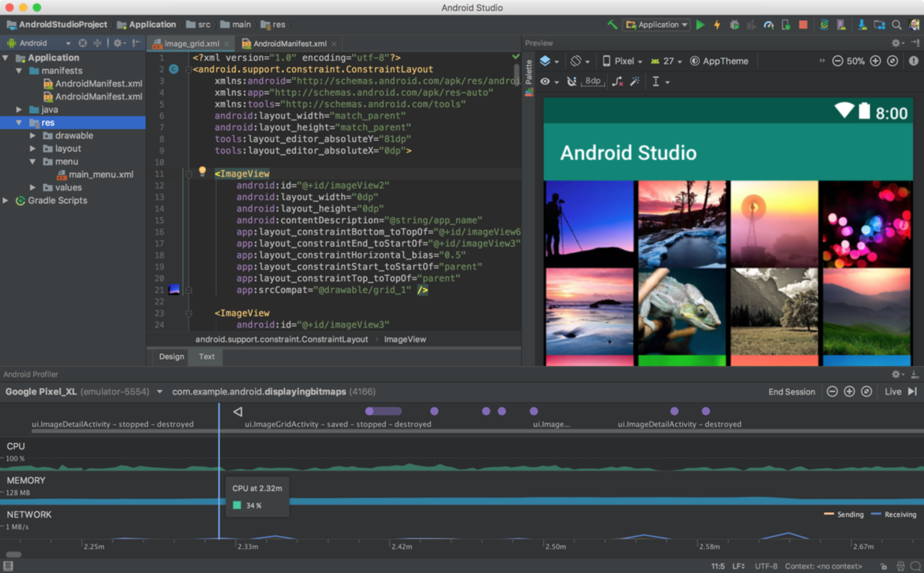

**Fig. 4.1 Interface of Android Studio**

**4.2 ARDUINO IDE**

The Arduino integrated development environment is a cross-platform application that is written in the programming language Java. It is used to write and upload programs to Arduino compatible boards. The Arduino IDE supplies software library from the wiring project, which provides many common input and output procedures.

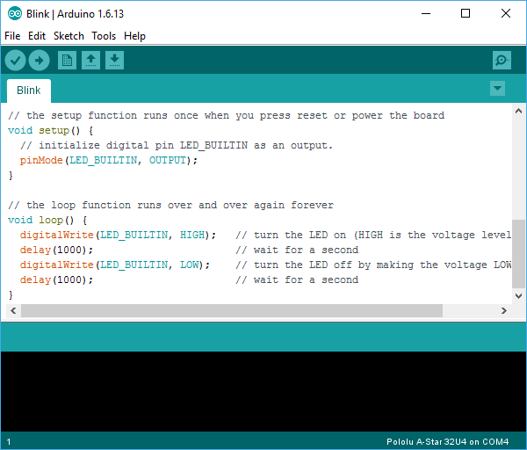

**Fig. 4.2 Interface of Arduino IDE**

**4.3 INTERFACING PROGRAM**

* **FUNCTION DECLARATION**

**<SoftwareSerial.h>**

**SoftwareSerial EspSerial(6, 7); // Rx, Tx**

**#include <stdlib.h>**

**// pin variable declaration**

**#define HARDWARE_RESET 8**

**#define FREEZE_LED 13**

**#define lpg_gas_sensor 10**

**#define servomotor 11**

**#define alarm 12**

* **VARIABLE DECLARATION**

**boolean lpg_sensor_status;**

**int spare;**

**long writeTimingSeconds = 17;**

**long readTimingSeconds = 10;**

**long startReadTiming = 0;**

**long elapsedReadTime = 0;**

**long startWriteTiming = 0;**

**long elapsedWriteTime = 0;**

**boolean knob;**

**boolean Alarm;**

**boolean error;**

**void setup()**

**{**

**// setup code to run once**

**Serial.begin(9600);**

**pinMode(HARDWARE_RESET,OUTPUT);**

**pinMode(lpg_gas_sensor,INPUT);**

**pinMode(servomotor,OUTPUT);**

**pinMode(FREEZE_LED,OUTPUT);**

**pinMode(alarm,OUTPUT);**

**digitalWrite(HARDWARE_RESET, HIGH);**

**digitalWrite(FREEZE_LED, LOW);**

**EspSerial.begin(9600);**

**EspHardwareReset();**

**startReadTiming = millis();**

**startWriteTiming = millis();**

**}**

**void loop()**

**{**

**start:**

**error=0;**

**elapsedWriteTime = millis()-startWriteTiming;**

**elapsedReadTime = millis()-startReadTiming;**

**if (elapsedWriteTime >(writeTimingSeconds*1000))**

**{**

* **CODE TO READ SENSOR DATA AND WRITE THE DATA ON THE WEBSITE (API.VIRTUALWORLD.TODAY)**

**ESPcheck();**

**readSensors();**

**writeWebsiteData("sensor_write",lpg_sensor_status);**

**startWriteTiming = millis();**

**}**

**if (error==1)**

**{**

**Serial.println(" <<<< ERROR >>>>\n");**

**digitalWrite(FREEZE_LED, HIGH);**

**delay (2000);**

**goto start;**

**}**

* **CODE TO READ THE DATA FROM THE WEBSITE FROM TABLE KNOB ACTION STATUS WHERE ANDROID APP WRITES THE DATA FOR REGULATORS AND ALARM**

**if (elapsedReadTime >(readTimingSeconds*1000))**

**{**

**ESPcheck();**

**int command = readWebsiteData("knob");**

**Serial.print(command);**

**if(command != 9){**

**knob = command;**

**}**

* **TAKING ACTIONS AFTER READING DATA FROM THE WEBSITE TABLE ACTION_STATUS**

**takeActions();**

**// writes the data on the website table knob and alarm status after executing the particular actions**

**writeWebsiteData("knob_write",knob);**

**command=0;**

**delay (1000);**

**command = readWebsiteData("alarm");**

**Serial.print(command+"\n");**

**if (command != 9){**

**Alarm = command;**

**}**

**takeActions();**

**writeWebsiteData("alarm_write",Alarm);**

**command=0;**

**startReadTiming = millis();**

**}**

**}**

* **FUNCTION TO READ SENSORS DATA**

**void readSensors(void)**

**{**

**lpg_sensor_status=digitalRead(lpg_gas_sensor);**

**Serial.println("Reading Sensor Data:##START");**

**Serial.println(lpg_sensor_status);**

**Serial.println("Reading Sensor Data:##END");**

**}**

* **FUNCTION TO WRITE DATA ON THE WEBSITE**

**VoidwriteWebsiteData(String write,boolean device)**

**{**

**startCmd();**

**String status;**

**if(device==1){**

**status="on";**

**}**

**else{**

**status="off";**

**}**

**Serial.println("Sending Sensor Data.....");**

**String getStr = "GET /"+write+".php?status="+status+" HTTP/1.1\r\nHost: api.virtualworld.today\r\nConnection: keep-alive\r\n\r\n";**

**Serial.println(getStr);**

**sendWebsiteGetCmd(getStr);**

**}**

**void EspHardwareReset(void)**

**{**

**Serial.println("Reseting.......");**

**digitalWrite(HARDWARE_RESET, LOW);**

**delay(500);**

**digitalWrite(HARDWARE_RESET, HIGH);**

**delay(8000);**

**Serial.println("RESET");**

**}**

* **START SERIAL MONITOR COMMAND TO SEND OR RECEIVE DATA TO WEBSITE**

**void startCmd(void)**

**{**

**EspSerial.flush();**

**String cmd = "AT+CIPSTART=\"TCP\",\"";**

**cmd += "api.virtualworld.today";**

**cmd += "\",80";**

**EspSerial.println(cmd);**

**Serial.print("Start cmd: ");**

**Serial.println(cmd);**

**if(EspSerial.find("Error"))**

**{**

**Serial.println("AT+CIPSTART error");**

**return;**

**}**

**}**

**String sendWebsiteGetCmd(String getStr)**

**{**

**String cmd = "AT+CIPSEND=";**

**cmd += String(getStr.length());**

**EspSerial.println(cmd);**

**Serial.print("lenght cmd: ");**

**Serial.println(cmd);**

**if(EspSerial.find(">"))**

**{**

**EspSerial.print(getStr);**

**Serial.print("REQUEST==>: ");**

**Serial.println(getStr);**

**delay(500);**

**String messageBody = "";**

**while (EspSerial.available())**

**{**

**String line = EspSerial.readStringUntil('\n');**

**if (line.length() == 1)**

**{**

**messageBody = EspSerial.readStringUntil('\n');**

**}**

**}**

**Serial.print("MessageBody received: ");**

**Serial.println(messageBody);**

**return messageBody;**

**}**

**else**

**{**

**EspSerial.println("AT+CIPCLOSE");**

**Serial.println("ESP8266 CIPSEND ERROR: RESENDING");**

**spare = spare + 1;**

**error=1;**

**return "error";**

**}**

**}**

* **FUNCTION TO READ DATA FROM THE WEBSITE**

**int readWebsiteData(String device_name)**

**{**

**startCmd();**

**String getStr = "GET /action_read.php?on"+device_name+" HTTP/1.1\r\nHost: api.virtualworld.today\r\nConnection: keep-alive\r\n\r\n";**

**String messageDown = sendWebsiteGetCmd(getStr);**

**Serial.print("Sending ...: ");**

**Serial.print("Receive Action status:..,............ ");**

**Serial.println(messageDown);**

**if(messageDown.indexOf("{STATUS[NOT TAKEN]STATUSEND}")>=0 && messageDown.indexOf("{ACTION[off]ACTIONEND}")>=0){**

**Serial.println("##\nTaking...Action.."+device_name+" off\n###\n");**

**Serial.print(device_name+"Action received .. ...: ");**

**return 0;**

**}**

**return 1;**

**}**

* **FUNCTION TO PERFORM ACTIONS ON REGULATOR OR ALARM**

**void takeActions(void)**

**{Serial.print("lpg_sensor_status is ");**

**Serial.println(lpg_sensor_status);**

**Serial.print("knob: ");**

**Serial.println(knob);**

**Serial.print("alarm: ");**

**Serial.println(Alarm);**

**if(knob == 1){**

**digitalWrite(servomotor, HIGH);**

**Serial.print("knob action performed");**

**}**

**else**

**digitalWrite(servomotor, LOW);**

**if (Alarm == 1){**

**digitalWrite(alarm, HIGH);**

**Serial.print("alarm action performed");**

**}**

**else**

**digitalWrite(alarm,LOW);**

**}**

**boolean ESPcheck(void)**

**{**

**EspSerial.println("AT");**

**if (echoFind("OK"))**

**{**

**digitalWrite(FREEZE_LED, LOW);**

**return true;**

**}**

**else**

**{**

**Serial.println("ESP Freeze********************************************”);**

**digitalWrite(FREEZE_LED, HIGH);**

**EspHardwareReset();**

**return false;**

**}**

**}**

**boolean echoFind(String keyword)**

**{**

**byte current_char = 0;**

**byte keyword_length = keyword.length();**

**long deadline = millis() + 5000; while(millis() < deadline){**

**if (EspSerial.available()){**

**char ch = EspSerial.read();**

**Serial.write(ch);**

**if (ch == keyword[current_char])**

**if (++current_char == keyword_length)**

**{**

**Serial.println();**

**}**

**}**

**}**

**return false**

**}**

**\*\*\*\*\* END OF THE PROGRAM \*\*\***

**5. PROJECT DESCRIPTION**

Generally all entire LPG gas sensor modules are made using microcontroller which are very much costly. The main objective of this design is to make the same corresponding circuit using ICs and Sensors. The purpose is to a send a notification through the smart phone so that if the person is not in the home then also he will get the notification through the mobile app and can control the regulator.

Also when the circuit will detect the gas leakage then it will turn the regulator in off position by rotating it through the servo motor.

**5.1 LPG GAS LEAKAGE DETECTOR CIRCUIT DESIGN IN EASYEDA SOFTWARE TOOLS**

As the circuit will detect the gas leakage it will blow the alarm to alert the persons nearby the leakage area and also at the same time it will send the notification to the person through the mobile app. On the mobile app, there will be the option of switching off the regulator knob that if the person is not in the house then also he can stop the gas leakage.

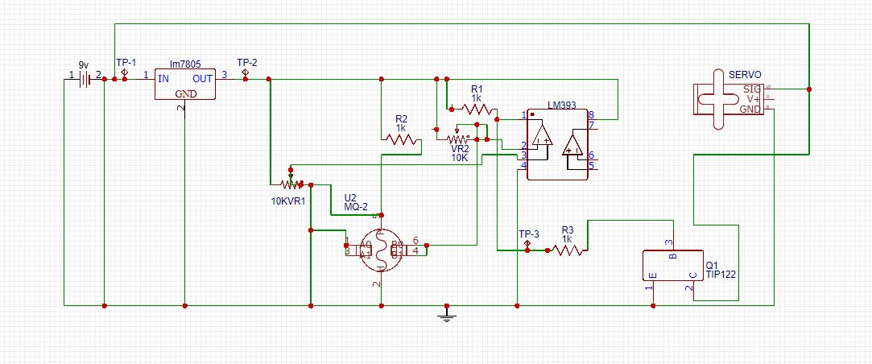

**Fig. 5.1 Circuit diagram of LPG gas leakage detector**

**5.2 INTERFACING OF ARDUINO WITH MQ-6 SENSOR**

MQ-6 gas sensor has 6 terminals having three pairs of pin called as A, B, H. The A terminal is connected to the ground and H is connected to power supply. The B terminal is the analog output terminal of the gas sensor which is connected to the analog input pin A1 of the Arduino Uno. The H terminal generates 0 to 5 volt output voltage on sensing the LPG gas depending upon the concentration of LPG in air and this output voltage is read by the Arduino Uno via analog input pin A1 and perform actions accordingly.

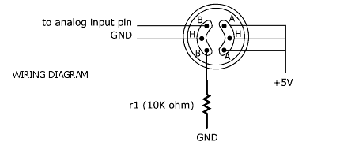

**Fig. 5.2 Pin Layout of the MQ-6 sensor**

**5.3 INTERFACING OF ARDUINO WITH WI-FI MODULE**

ESP8266 WIFI module is a wi-fi that connects Arduino to a particular wi-fi network. It has 6pins as in the given diagram .The pins of ESP8266 is connected accordingly .Then it will connect to the wi-fi network having name “NIPU1” and access internet via this network and sends and receives data via web server api.virtualworld .today.

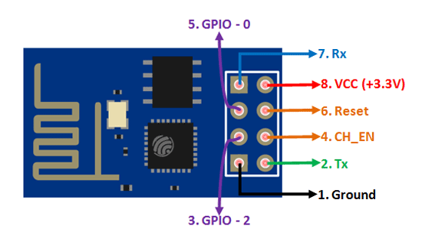 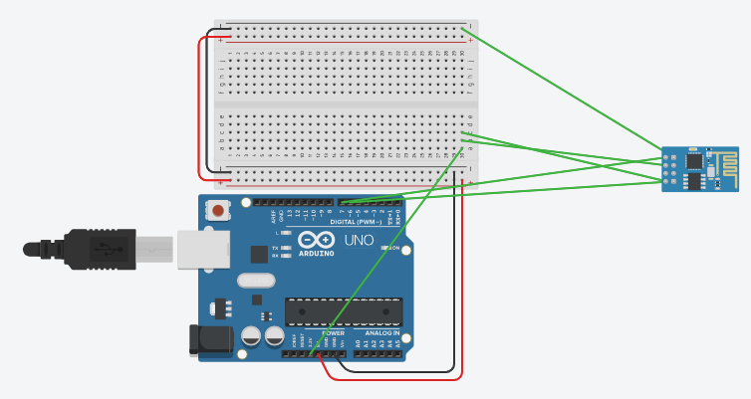

**Fig. 5.3. Interface diagram of Arduino with wi-fi module**

**5.4 INTERFACING OF ARDUINO WITH SERVO MOTOR AND ALARM** The dc servo motor is connected with +5 volt dc supply and the input control terminal of the servo motor is connected with the digital pin 11 of the Arduino and it is the output pin for the Arduino which is controlled via android app by the user.

The alarm is connected with the digital pin 12 of the Arduino and it is controlled via user android app.



**Fig. 5.4 Interface diagram of Arduino board with servo motor**

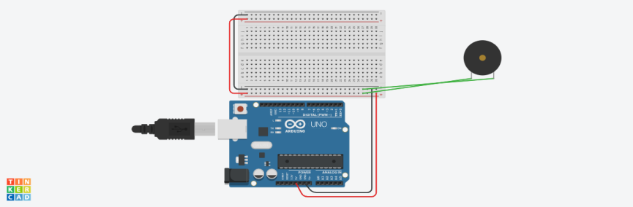

**Fig.5.5 Interface diagram of Arduino board with alarm**

**5.5 INTERFACING OF ARDUINO WITH MOBILE APP**

WEB SERVER ANDROID APP

LPG SENSOR STATUS

SENSOR STATUS

ALARM STATUS

ALARM STATUS

KNOB STATUS

ALARM ON OR OFF

KNOB STATUS

WIFI NETWORK

REGULATOR ON OR OFF

ACTION KNOB STATUS

ARDUINO UNO

ACTION ALARM STATUS

ESP8266 WIFI

**Fig.5.6 Interfacing of web server with Arduino and android app**

**5.7ANDROID INTERFACING WITH WEB SERVER**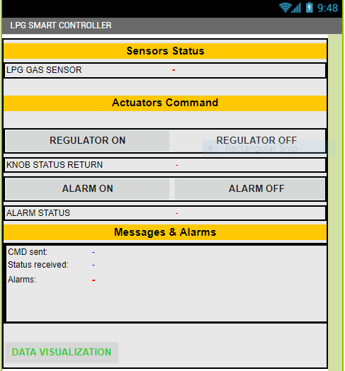

Reads the LPG gas sensor status from the website table sensor status

Writes 1 the table action knob status on the website to turn the regulator ON

Writes 0 the table action knob status on the website to turn the regulator OFF

Reads the data 1 or 0 from the website table knob status which is given by the Arduino after performing the respective action and writes here

Writes 1 the table action alarm status on the website to turn the alarm ON

Reads the data 1 or 0 from the website table alarm status which is given by the Arduino after performing the respective action and writes here

Writes 0 the table action alarm status on the website to turn the alarm OFF

Gives An alert notification if the lpg leakage is there or LPG sensor status is 1

Provides the status of all data received and send by the Arduino and android app via website api.virtualworld.today

**Fig.5.7 Interface diagram of android with web server**

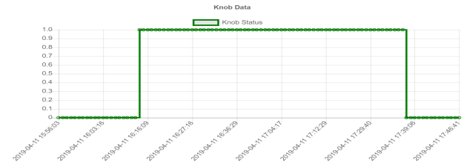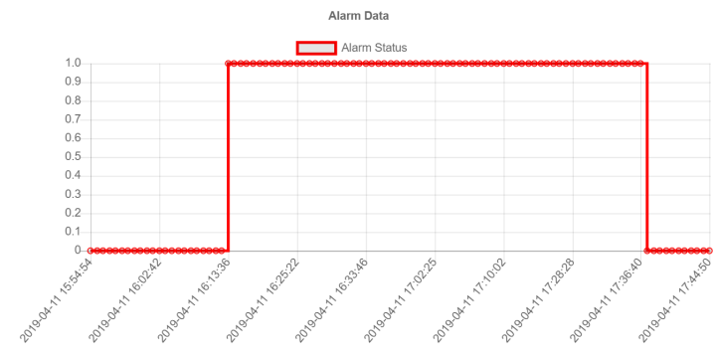**5.8 WEB SERVER SQL DATABASE**

–

Alarm status

Gas Regulator Knob

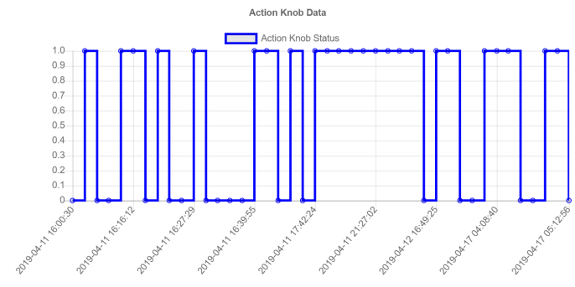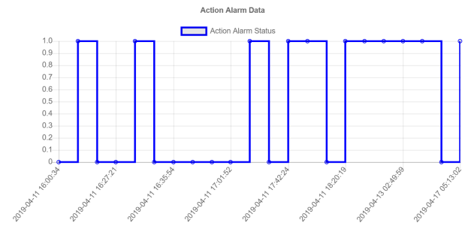

Gas Regulator Knob action status

Alarm action status

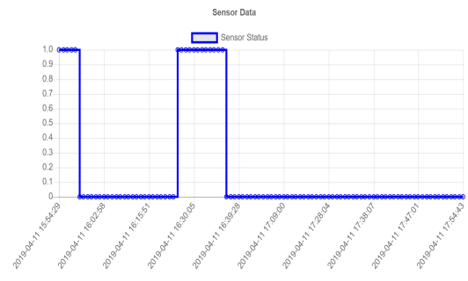

Gas sensor status

**Fig.5.8 Web Server Data Table (**<http://api.virtualworld.today/>)

**5.9 HARDWARE SETUP OF LPG LEKAGE DETECTOR**

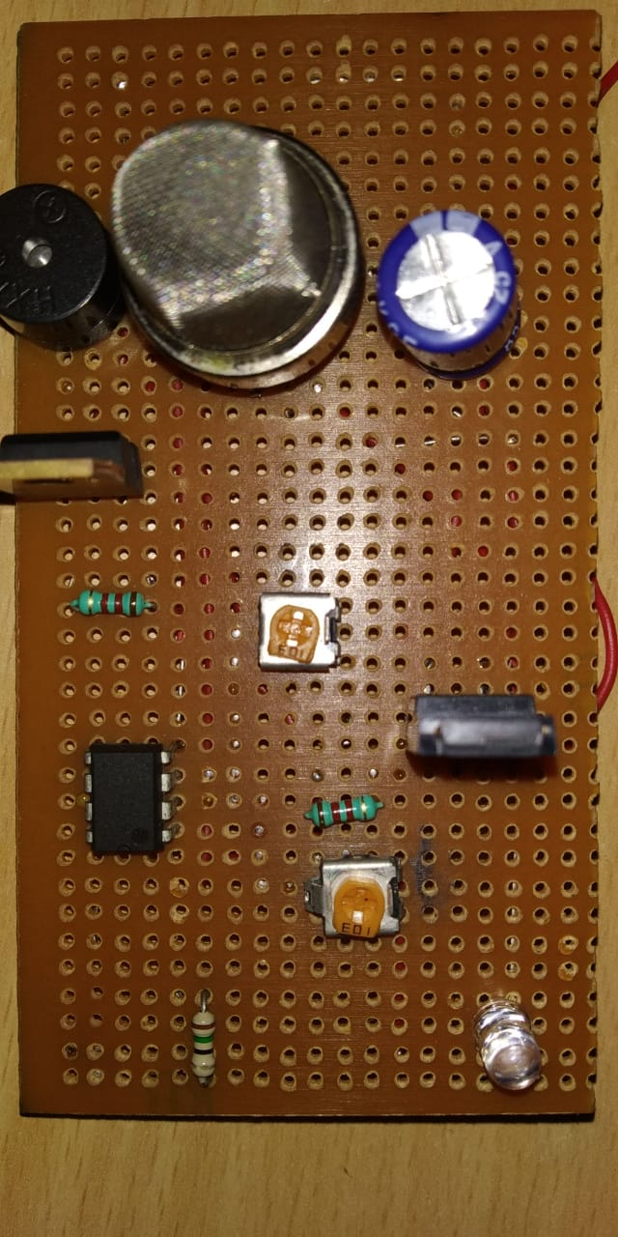**\**

CAPACITOR-1000uf,25V

PIEZO BUZZER

1K RESISTORR

LM393 OP-AMP

OP-AMP

ON/OFF LED

IC 7805

10K POTMETER

MQ-6 GAS SENSOR

**Fig. 5.9 Hardware setup of the project**

**6. PROJECT OUTCOME**

While working on this project we come to know about many electronics hardware like MQ-6 gas sensor, IC7805, LM393, Arduino board, WI-FI module, Piezeo buzzer etc and software tools like Android Studio for designing the mobile application and Arduino IDE for interfacing sensor. We come to know about their necessity in designing the hardware. Also we learned how to do interfacing of Arduino board with the different modules with the help of software and programming. In this project we learnt how to use Android Studio to develop a mobile application which will do the input/output operation from the server and show the notification to the user on his display device. We learned how to use Arduino IDE flat form to do the programming in C language. In this we come to know how to send and receive data from the server.

**TABLE FOR COST ESTIMATION**

**Table 1: cost estimation of required hardware components**

|  |  |  |  |
| --- | --- | --- | --- |
| **SL.NO** | **HARDWARE** | **QUANTITY** | **PRICE(Rs)** |
| 1. | MQ-6 LPG GAS SENSOR | 1 | 150 |
| 2. | ARDUINO UNO | 1 | 450 |
| 3. | ESP8266 WI-FI MODULE | 1 | 300 |
| 4. | SERVO MOTOR | 1 | 120 |
| 5. | LM393 | 1 | 10 |
| 6. | LM7805 | 1 | 15 |
| 7. | PCB BOARD | 1 | 20 |
| 8. | PIEZO BUZZER | 1 | 40 |
| 9. | BREAD BOARD | 1 | 50 |
| 11. | BASICELECTRONICS COMPONENTS  RESISTOR(3),CAPACITOR(1),POTENTIOMETER (2),LED (1) | 7 | 20 |
|  | **TOTAL** | | 1,175 |

**7. APPLICATIONS**

This project has a wide application in home automation and it seeks a huge demand necessary home safety appliances.

* In kitchen gas cylinder
* In gas godowns
* In Hospitals and laboratories
* In Industries application

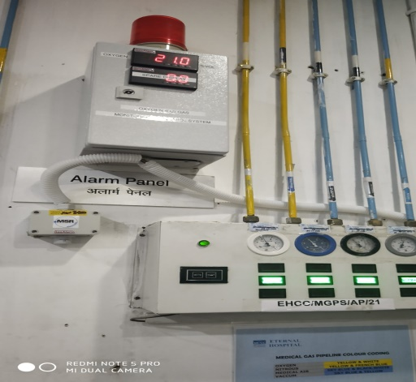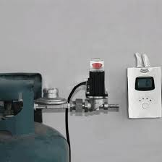 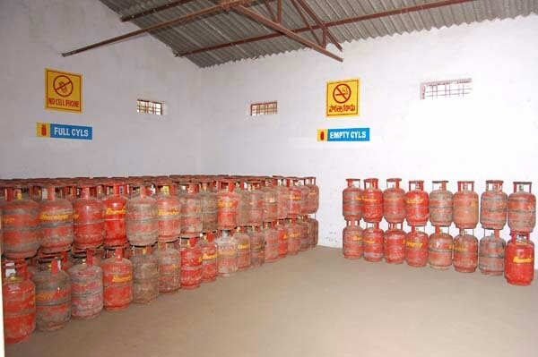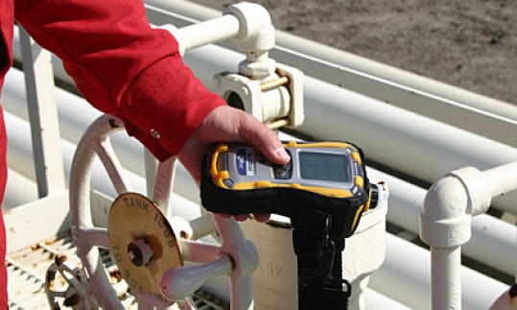

**Fig.7.1 (a) Installed gas leakage detector near a LPG cylinder (b) LPG gas godown**

**(c) industrial leakage device (d) hospital gas leakage alarm**

1. **CONCLUSION**

In this project we able to interface different hardware modules like gas sensor, wi-fi module, and servo motor with Arduino IDE software and learnt how to use IoT to make our life more better and safer.

By testing the circuit in the real time environment we found that it is working properly as per the requirement of the project. This device will reduce the risks of hazards caused by the LPG gas leakage. By using the basics components of electronics we can design a hardware which can sense and detect LPG gas in the surrounding and make the people aware of it through the alarm system as well as the mobile application.

**REFERENCES**

[1] Wickramasinghe, M. G. D. D., and N. Abhayasinghe. "LPG Gas Leakage Alarm." *SAITM Research Symposium on Engineering Advancements*. 2013.

[2] [https://www.business-standard.com/article/pti-stories/cooking-gas-cylinder-explosion-3- killed-in-odisha-118111400587_1.html](https://www.business-standard.com/article/pti-stories/cooking-gas-cylinder-explosion-3-%20%20%20killed-in-odisha-118111400587_1.html)

[3] <https://www.arduino.cc/>

[4] <https://www.tutorialspoint.com/android/android_studio.htm>

[5] <https://components101.com/sensors/mq-6-gas-sensor-pinout-equivalent-datasheet>